Quick Start
Welcome to Import Excel RF System Chain utility.
1. Select and specify the desired spreadsheet parameters.
2. Click the 'Read Excel Data' button to import Excel data into the program.
3. Click the 'Select and Run Workspace' button. Browse to the “Spreadsheet_Template.*” file. The simulator will open. Then run the analysis.
Note: Defaults to a maximum of 30 Stages. To increase number of stages refer to section Updating the Spreadsheet_Template.* file
How it works
The referenced cells are used to obtain data from the user’s Excel file. There are checkboxes for the user to choose which data they want to extract and move from the Excel. When the user clicks the ‘Read Excel data’ button the referenced cells are identified in Excel, extracted, and stored into a numerical array. The extracted values as well as any errors such as references to empty cells, invalid data, or unidentified cells are displayed in the log window.
Click the 'Select and Run Workspace' button to migrate the extracted data from Excel into the Spectrasys template file called ‘Spreadsheet Template.*’. The user will be prompted to select this template file. The template file will be populated with values extracted from Excel and Spectrasys will be launched in the simulator. The Part Designator name is used to distinguish the order and locations of stages in the template workspace.
Due to limitations in cascaded analysis and its implementation in spreadsheets only two models are needed to map a cascaded analysis to a simulator. They are the Attenuator and Amplifier models. See the Cascaded Analysis – Spreadsheets for the reasons why.
From the spreadsheet data the program will automatically determine whether to use an Attenuator or Amplifier. An attenuator is selected when Gain is negative and its absolute value is within a 0.001 tolerance of the Noise Figure. In order to properly catch a passive mixer an additional test looks for a 1 dB Compression Point greater than 60 dBm. If the 1 dB compression point is less than 60 dBm an Amplifier will be selected.
The 4 nonlinear parameters, P1dB, Psat, IP3, and IP2 are needed by the Spreadsheet_Template.* file. However, the spreadsheet may not contain all of these parameters. This conversion tools will use general rules of thumb to create missing non-linear parameters based on the following relationships:
- Psat = P1dB + 3 dB
- IP3 = P1dB + 10 dB
- IP2 = P1dB + 20 dB
When the ‘Input Referenced Nonlinear Parameters’ checkbox is checked, all entries in the spreadsheet are assumed to be input referenced. Since the attenuator and amplifiers have output referenced parameters any input referenced parameters will be converted using the following equations:
- OP1dB = IP1dB + Gain – 1
- OPsat = IPsat + Gain
- OIP3 = IIP3 + Gain
- OIP2 = IIP2 + Gain
The ‘Spreadsheet_Template.*’ file by default uses 30 cascaded attenuators. If the spreadsheet has less than 30 stages any unused stages will be shorted out in the template file. The attenuator model will be changed to an amplifier model based on the conditions mentioned above.
The user can modify the ‘Spreadsheet_Template.*’ file to add additional stages. To do so, click an attenuator and select Ctrl+D to duplicate this model. Insert the duplicated attenuator between the last attenuator and isolator at the end of the chain. Change the Part Designator name to be consistent with the pattern for the rest of the attenuators. This utility tool looks for these part designator names. The format should be Part_x where x is the stage number.
Cascaded Analysis - Spreadsheets
Traditional cascaded equations have serious limitations. Some of the main issues are:
- Scalar calculations
- No frequency response
- No mismatch loss
- No compression effects
- No intermod generation
- No spurious analysis
- Limited to two ports
- Single path analysis
- No leakage paths
- No broadband noise analysis
- Amplifiers noise figure ignores source impedance
- No mixer image noise
For these reasons it becomes trivial to model a spreadsheet cascaded analysis with attenuators and amplifiers. Since there is no such thing as frequency response a spreadsheet filter must be modeled as an attenuator. Attenuators have constant attenuation and matched at all frequencies. Amplifiers are needed to calculated intercept and compression points. However, in the simulator the amplifier models will generate intermods and can go into compression. Be careful about drive level when comparing Spectrasys results to those in the spreadsheet.
For additional information see the help section in Simulation > Spectrasys > Spectrasys Fundamentals > Cascaded Analysis – Spreadsheet Limitations in the simulation software.
Walkthrough Example
- Identify the desired Spreadsheet references
After running the .exe, a tool will appear. In the correct boxes fill in the references for the Spectrasys data. Data is organized in either rows or columns. Using the example Spreadsheet ‘Cascaded Analysis.xlsx’ here is what the filled UI will look like below, organized in Columns (To see what organized in rows and columns means, look at examples of each in Figures at the end of the Walkthrough).
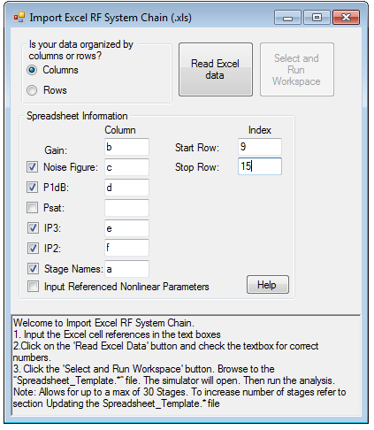
- Click ‘Read Excel Data’
After inputting all the data, click on the ‘Read Excel data’ button and the rich text box will look like the following
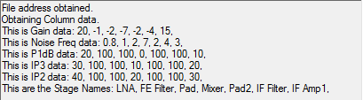
- Click on 'Select and Run Workspace'
Check each value to check that it matches with the spreadsheet. If there are any errors, they will be displayed on the rich text box. Click on 'Select and Run Workspace' to write the data into Spectrasys. This may take a minute or two.
- Open Spectrasys and do analysis
When all the data is written to Spectrasys, Spectrasys will be displayed, and you can do analysis with the data. The data written into Spectrasys will looks something like below.
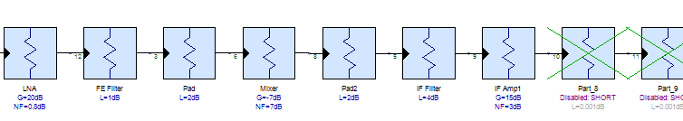
- Examples of data organized in rows and columns
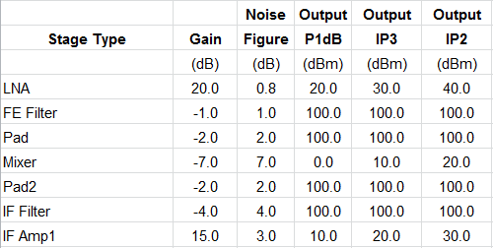
Figure 1: Data organized in columns
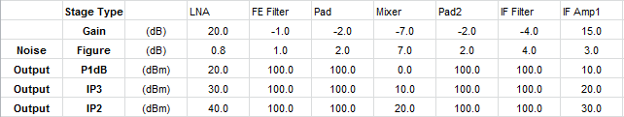
Figure 2: Data organized in rows
Updating the Spreadsheet_Template.* file
To edit, the Spreadsheet_Template.* file to increase the default range,
- Find the Spreadsheet_Template.* file in the same folder as the Excel to Spectrasys executable and open the file in simulation software.
- Copy any of the Attenuator parts, and paste the number of parts to add onto the schematic. Make sure that the parts are ordered sequentially when connecting them, and that the schematic ends with Part_# -> Isolator -> Out.
- Save the file anywhere on the local machine, or can choose to overwrite the default Spreadsheet_Template.* file, and locate this file when using the Excel to Spreadsheet executable.
Selecting Simulation Software Version to Run
The tool will automatically run the simulation software version that was last registered. To register a different simulation software version,
- Run the windows command prompt as administrator
- Find the desire version in ‘Program Files’ or ‘Program Files (x86)’ and change directory to the Bin
- Run the following commands to either unregister or register
  - *.exe /regserver
  - *.exe /unregserver
Limitations
- The only spreadsheet supported is Excel
- The tool can only take stage names that are unique, as Spectrasys will only take unique stage names.
- Empty spreadsheet cells are treated as errors (Empty stage names are given a default name)
- The utility tool has an upper limit of 100 stages (the Spreadsheet_Template.* file only supports 30 stages by default but this can get edited by the user)
- The nonlinear parameters that are not checked are calculated mathematically using the other parameters. The values used come in order by how they appear in the tool (See ‘How it works’ for relationship)

